
REPORT ON FIELD TRIP TO GHANA DIGITAL CENTRES LIMITED (GDCL),
FOR THE PROGRAMME OF STUDY OF BSC COMPUTER SCIENCE CYBERSECURITY
OF THE COMPUTER SCIENCE DEPARTMENT OF
THE GHANA COMMUNICATION TECHNOLOGY UNIVERSITY
BY
NAME: ISAAC YAO AFETOR
INDEX-NUMBER: 1704526414
LECTURER: DR. MARTIN MABEIFAM UJAKPA
JANUARY 2026.

Table of Contents
List of Figures iii
List of Tables iv
Abstract v
1.1. INTRODUCTION 1
1.2. INDUSTRY: INFORMATION AND COMMUNICATION TECHNOLOGY (ICT) 1
1.3. COMPANY: GHANA DIGITAL CENTRES LIMITED (GDCL) 1
1.3.1. DEPARTMENT: SECURITY OPERATIONS AND INFRASTRUCTURE MANAGEMENT FUNCTION 2
1.4. Chosen Company Operations, Activities & Resources 2
1.5. Operational Effectiveness and efficiencies of the chosen company & Department 2
1.5.1. Challenges 2
1.5.2. Analysis 3
1.5.3. Proposed Solution 3
1.5.4. Expected Benefits 3
1.6. Proposed Solution Specifications and Design 4
1.6.1. Agile Development Methodology 4
1.6.2. Requirement Analysis 4
1.6.2.1. Functional Requirements 4
1.6.2.2. Non-functional Requirements 4
1.6.2.3. Hardware Requirements 5
1.6.2.4. Software Requirements 5
1.6.2.5. Sprints and Iterations 5
1.6.2.6. User Stories 5
1.6.2.7. Continuous Integration and Testing 6
1.6.2.8. Adaptability to Change 6
1.6.3. System Design 6
1.6.3.1. System Architecture 6
1.6.3.2. Use Case Diagram 8
1.6.3.3. Sequence Diagram 8
1.6.3.4. User Interface Design 9
1.7. Proposed solution Development 9
1.7.1. Development Technology and Tools Specifications 9
1.7.1.1. Software (programming languages, IDEs, runtime platforms) 9
1.7.1.2. Hardware (development and production) 10
1.7.2. Network specifications and deployment considerations 11
1.7.2.1. Network specifications 11
1.7.2.2. Developed solution and associated code 11
1.8. SYSTEM TESTING 26
1.8.1. Unit Test Purpose 26
1.8.2. Integration Testing Purpose 27
1.8.3. System Testing Purpose 27
References 29

List of Figures
Figure 1 SYSTEM ARCHITECTURE 7
Figure 2 USE CASE DIAGRAM 8
Figure 3 SEQUENCE DIAGRAM 9
Figure 4 SECURITY OVERVIEW DASHBOARD 12
Figure 5 COMPLETE DASHBOARD VIEW 13
Figure 6 SECURITY METRICS 13
Figure 7 CRITICAL ALERTS 14
Figure 8 SECURITY EVENT LOGS 14
Figure 9 EVENT TIME-LINE GRAPH 15
Figure 10 ALERT RULES CONFIGURATION 15
Figure 11 LOGSTASH PIPELINE STATUS 16
Figure 12 FIREWALL ANALYSIS DASHBOARD 17
Figure 13 AUTHENTICATION MONITORING 18
Figure 14 RECENT SECURITY EVENT 19
Figure 15 ALERT RULES – BRUTE-FORCE-DETECTION 19
Figure 16 ALERT RULES – IMPORT ALERTS 20
Figure 17 ALERT RULES – MALICIOUS -IP-ALERT 21
Figure 18 ALERT RULES – FAILED-LOGIN-THRESHOLD 21
Figure 19 CONFIG - FILEBEAT 22
Figure 20 CONFIG - WINLOGBEATS 22
Figure 21 CONFIG – ELASTICSEARCH 23
Figure 22 CONFIG – KIBANA 24
Figure 23 CONFIG - LOGSTASH 24
Figure 24 CONFIG - PIPELINES 25
Figure 25 DASHBOARD 25
Figure 26 OTHER FILES 26

List of Tables

Abstract
This report summarises a field study of the Security Operations and Infrastructure Management function at Ghana Digital Centres Limited (GDCL), conducted to evaluate operational security practices and propose a computerised solution to improve threat detection and response. Through direct observation and interviews during the field visit, the study found a predominantly device-centric, manual approach to security monitoring that produces fragmented visibility, high analyst workload, and extended Mean Time to Detect (MTTD) and Mean Time to Respond (MTTR). Root causes include a heterogeneous technology stack, limited budgetary prioritisation for security tooling, and a skills gap in specialised cybersecurity domains. To address these issues the report proposes a Centralised Security Operations Dashboard (a “SOC-lite”) built on the Elastic Stack (Elasticsearch, Logstash, Kibana) with Beats for log collection, supplemented by automation, configuration-as-code, and CI pipelines. The solution specification covers functional and non-functional requirements, hardware and software needs, an Agile delivery plan with sprint milestones, example ingestion pipelines and parsers, and a comprehensive testing strategy (unit, integration, and system testing). Expected benefits include improved visibility and forensic capability, reduced MTTD/MTTR, operational scalability, and lower analyst burnout. The report concludes with implementation guidance, network and security hardening recommendations, and a phased rollout plan consistent with Ghana’s Data Protection Act.

1.1. INTRODUCTION
The rapid expansion of Ghana's digital economy necessitates a corresponding maturation in its defensive cybersecurity capabilities. For critical technology hubs like the Ghana Digital Centres Limited (GDCL), maintaining a secure environment requires a robust, efficient, and scalable operational security posture. Effective security operations enable an organisation to detect, analyse, and respond to cyber threats in a timely manner, thereby minimizing potential impact (NIST, 2020). This report presents a field study analysis of the security operations function at GDCL. It investigates the methodologies, processes, and tools used for security monitoring and incident response, aiming to identify systemic inefficiencies and propose a computerised solution to transition the organisation from a reactive to a proactive security model.

1.2. INDUSTRY: INFORMATION AND COMMUNICATION TECHNOLOGY (ICT)
Ghana Digital Centres Limited (GDCL) operates within the Information and Communication Technology (ICT) industry, a dynamic sector that underpins the entire Ghanaian economy. The ICT industry was chosen for this study due to its inherent operational complexity and the immense volume of event data it generates. Modern digital platforms and networks produce a constant stream of logs that must be monitored for malicious activity, making the ICT sector an ideal environment to study the challenges of operational security at scale (Gartner, 2021).

1.3. COMPANY: GHANA DIGITAL CENTRES LIMITED (GDCL)
Ghana Digital Centres Limited (GDCL) is a state-owned enterprise mandated to lead the development of technology parks across Ghana. Its flagship Accra Digital Centre provides critical digital infrastructure to a diverse portfolio of tenants (GDCL, 2023). GDCL was selected for this analysis because its role as a central infrastructure provider means a security failure could have cascading consequences for the many technology companies that depend on its services (ISACA, 2023).

1.3.1. DEPARTMENT: SECURITY OPERATIONS AND INFRASTRUCTURE MANAGEMENT FUNCTION
This report's observational focus was on the Security Operations and Infrastructure Management Function within GDCL's technical team. The study examined the procedures for monitoring network traffic, managing security devices, analysing system logs, and responding to technical alerts to assess the efficiency of the existing operational workflow.

1.4. Chosen Company Operations, Activities & Resources
The security operations at GDCL are characterized by a hands-on, device-centric approach. The team's activities primarily revolve around device-level log inspection on a case-by-case basis, active management of firewall policies, and handling alerts from disparate, non-integrated sources. When a security event is suspected, an administrator must engage in manual incident correlation by piecing together information from these various systems. A significant portion of the team's work is driven by reactive troubleshooting triggered by tenant complaints. The resources for these activities consist of a small team of skilled IT generalists using the native management interfaces provided by their hardware and software vendors.

1.5. Operational Effectiveness and efficiencies of the chosen company & Department
The GDCL technical team is highly effective at maintaining system uptime and ensuring service availability. However, from a security perspective, the model is inefficient. By focusing on individual devices rather than a holistic system view, the team operates in a perpetually reactive mode. This approach is ill-suited for identifying complex cyber-attacks that manifest across multiple systems over time (ENISA, 2022).

1.5.1. Challenges
The current operational methodology presents several challenges. The lack of centralised security visibility makes it nearly impossible to correlate seemingly unrelated events into a coherent attack chain. This contributes to a high Mean Time to Detect (MTTD), providing adversaries a wider window of opportunity. The manual review of vast quantities of raw logs leads to significant analyst fatigue, increasing the risk that a critical threat indicator may be overlooked (SANS Institute, 2022). Furthermore, this manual framework is inherently unscalable and will become untenable as GDCL and its data volumes grow.

1.5.2. Analysis
The challenges within GDCL's security operations are symptomatic of deeper, systemic factors. The primary root cause is the organic growth of a heterogeneous technology stack, where systems from different vendors do not natively integrate. This is compounded by budgetary constraints that often prioritise immediate operational needs over strategic investments in comprehensive security platforms. A global skills gap in specialised cybersecurity domains further forces a reliance on manual processes. These factors collectively create an environment where the security team struggles to keep pace with the data volume and evolving threat landscape.

1.5.3. Proposed Solution
To address the identified gaps, the proposed computerised solution is the implementation of a Centralised Security Operations Dashboard, acting as a "SOC-lite" system. This solution will automate the collection, aggregation, and analysis of security event data from all critical infrastructure. It will ingest logs into a unified platform and use a correlation engine to identify suspicious patterns in real-time. The output will be a web-based dashboard providing a single-pane-of-glass view of the organisation's security status, with prioritised alerts to enable a proactive posture.

1.5.4. Expected Benefits
The implementation of the Centralised Security Operations Dashboard is expected to yield substantial benefits. It will provide a dramatic enhancement in security visibility, leading to a significant reduction in the Mean Time to Detect (MTTD) and Mean Time to Respond (MTTR). By automating manual log review, the system will drive operational efficiency, reducing analyst burnout and allowing staff to focus on higher-value tasks like proactive threat hunting. The centralised log repository will also greatly strengthen forensic capabilities, and the system's inherent scalability will ensure it can support GDCL's long-term growth.

1.6. Proposed Solution Specifications and Design
The following sections detail the specifications for the Centralised Security Operations Dashboard. This system is designed to provide GDCL with a unified view of its security posture and transition the team from reactive troubleshooting to proactive threat detection.

1.6.1. Agile Development Methodology
The project will be implemented using the Agile Methodology. This iterative approach is ideal for this project as it allows for the incremental integration of different log sources. The first sprint can focus on integrating a single, high-value data source, like firewall logs, delivering immediate value. Subsequent sprints can then build on this foundation by adding more data sources and features based on feedback from the IT team (Fowler, 2005).

1.6.2. Requirement Analysis
A thorough analysis of the project's objectives has yielded a set of functional and non-functional requirements that will guide the implementation of the platform.

1.6.2.1. Functional Requirements
The platform must provide several core capabilities to be effective. A central function is Log Ingestion, where the system collects data from diverse sources such as firewalls, servers, and network devices. The system shall then perform Data Parsing and Normalization, transforming raw logs into a structured, common schema for consistent analysis. A critical component is the Correlation and Alerting engine, which will analyse the data stream in real-time to identify patterns indicative of threats and trigger automated notifications. Finally, a robust Data Visualization and Dashboarding module is required to provide security analysts with a clear, graphical, and interactive interface for monitoring and investigation.

1.6.2.2. Non-functional Requirements
The non-functional requirements define the quality attributes of the system. Scalability is paramount; the system must be horizontally scalable, allowing GDCL to add more nodes to the cluster to handle increasing log volumes. The system must also exhibit high Performance, characterized by a high data ingestion rate and fast query response times. Availability is a critical concern, with the system needing to operate continuously with minimal downtime to ensure no gaps in security monitoring. Data Integrity and Security must be guaranteed, with logs stored in a secure, tamper-evident manner and access controlled via a role-based access model. All data handling must follow Ghana's Data Protection Act, 2012 (Act 843).

1.6.2.3. Hardware Requirements
The platform will be designed to be cloud-hosted to ensure scalability and reliability. The production environment would require a cluster of virtual servers optimised for data processing. A minimal production cluster would consist of at least three dedicated nodes, each configured with significant memory (e.g., 32-64 GB RAM) and fast SSD storage (e.g., 1-2 TB) to handle the demands of data indexing and searching. A smaller, single-node setup would be used for development and staging. End-users will require no specialised hardware; the platform will be accessible via any standard web browser.

1.6.2.4. Software Requirements
The production servers will operate on a stable Linux distribution, such as Ubuntu Server. The core of the proposed solution is the Elastic Stack (ELK), which includes Elasticsearch for indexing and storage, Logstash for data processing, and Kibana for data visualization. Data collection from source systems will be handled by the Elastic Beats framework (e.g., Filebeat, Winlogbeat). For configuration management and deployment, tools such as Git and Ansible will be utilised to enable an infrastructure-as-code approach, ensuring consistency and repeatability.

1.6.2.5. Sprints and Iterations
The project will be broken down into four two-week sprints. Sprint 1 will focus on the initial setup of the core ELK cluster and ingesting the first high-priority log source, such as the perimeter firewall. Sprint 2 will expand on this by adding server logs and building the first set of operational dashboards in Kibana. Sprint 3 will be dedicated to developing and implementing the initial set of correlation rules and configuring the alerting mechanism. The final sprint, Sprint 4, will be reserved for user acceptance testing (UAT) with the IT team, performance tuning, and creating documentation.

1.6.2.6. User Stories
The implementation process will be guided by user stories to ensure features are practical and provide immediate value. Key stories include: "As a Security Analyst, I want to see a graph of all failed login attempts across all servers on one dashboard, so I can spot brute-force attacks." Another is: "As an IT Administrator, I want to receive an email alert when the firewall blocks traffic from a known malicious IP address, so I can investigate immediately." Finally: "As a Manager, I want a monthly report of all critical security events, so I can track our security posture and justify security spending."

1.6.2.7. Continuous Integration and Testing
While this is an infrastructure project, principles of continuous integration will be applied to configuration management. All configurations for Logstash, Elasticsearch, and Kibana dashboards will be managed as code in a Git repository. A CI pipeline will automatically validate the syntax of configuration files upon commit. Automated tests will be run to ensure parsing rules for new log sources work as expected before they are deployed to the production cluster, reducing the risk of misconfigurations.

1.6.2.8. Adaptability to Change
The system's architecture, based on the Elastic Stack, is inherently designed for adaptability. New log sources can be integrated by simply deploying a new Beat agent and adding a new parsing pipeline in Logstash, with no changes required to the core cluster. The use of a common schema (Elastic Common Schema) ensures that new data sources are immediately compatible with existing dashboards and correlation rules. This modularity allows the system to easily adapt to any new technologies GDCL may adopt in the future.

1.6.3. System Design
The system's design is based on a robust data-processing pipeline architecture, ideal for handling large streams of event data.

1.6.3.1. System Architecture
The platform's architecture is a data pipeline model. Lightweight agents (Filebeat) are installed on data sources to ship logs to a central processing engine (Logstash). Logstash parses and enriches the data before sending it to a distributed search and analytics engine (Elasticsearch) for indexing and storage. A visualization layer (Kibana) then queries Elasticsearch to provide dashboards and a search interface to the user.
The diagram below provides a visual representation of this architecture.
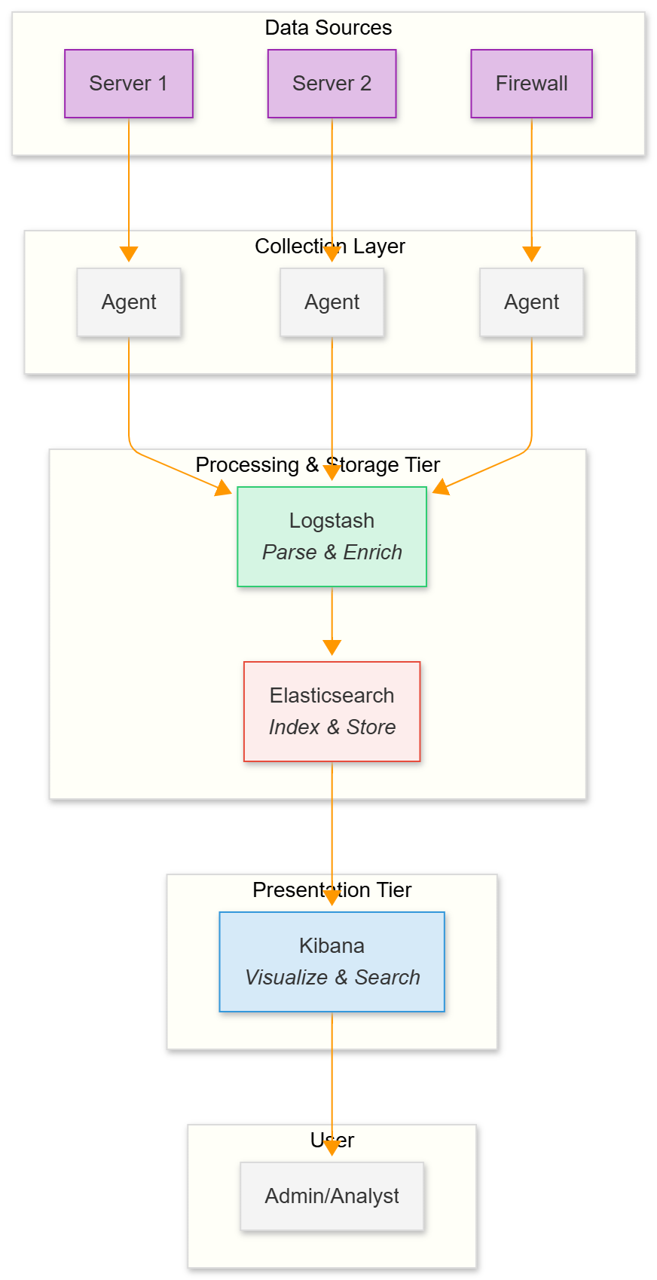
Figure 1 SYSTEM ARCHITECTURE

1.6.3.2. Use Case Diagram
The primary actor for this system is the Administrator/Security Analyst. Key use cases include viewing security dashboards, searching all logs from a single interface, creating and managing alert rules, and investigating security incidents by exploring correlated data.
The diagram below illustrates the key use cases and the actors who perform them.
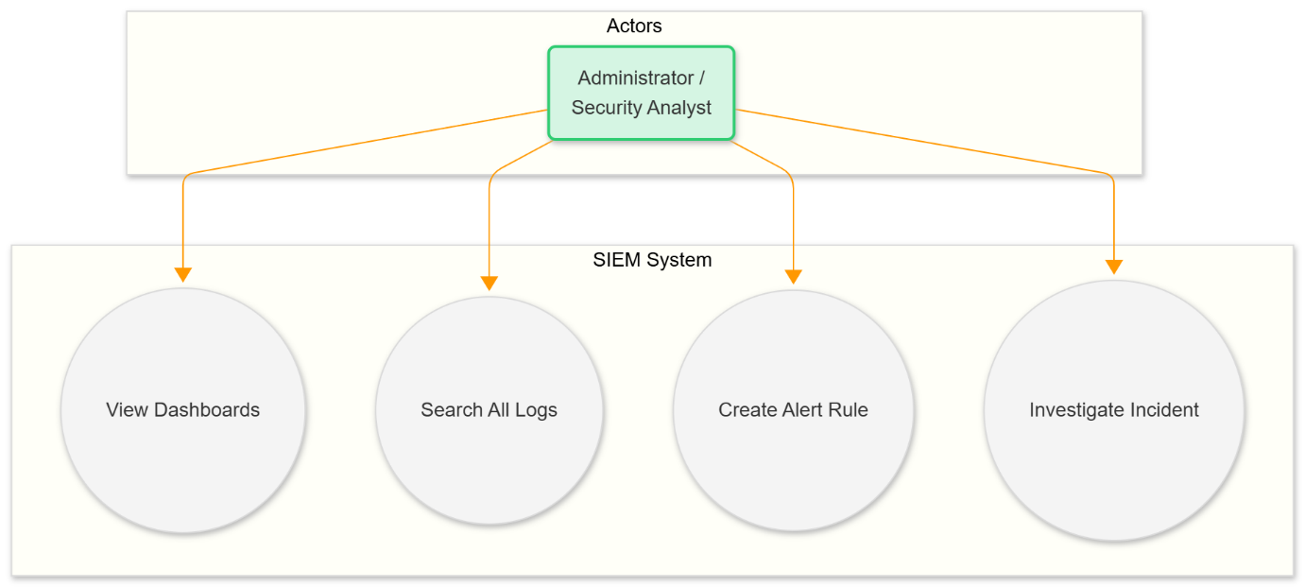
Figure 2 USE CASE DIAGRAM

1.6.3.3. Sequence Diagram
A typical data flow sequence begins with an event occurring on a monitored server, which writes a line to a log file. The agent immediately detects and forwards this log entry to the processing engine. The engine parses the entry, transforms it into a structured format, and indexes it in the analytics engine. The new data is then almost instantly available for searching and visualization by the analyst.
The sequence diagram below details the step-by-step flow of this data pipeline.
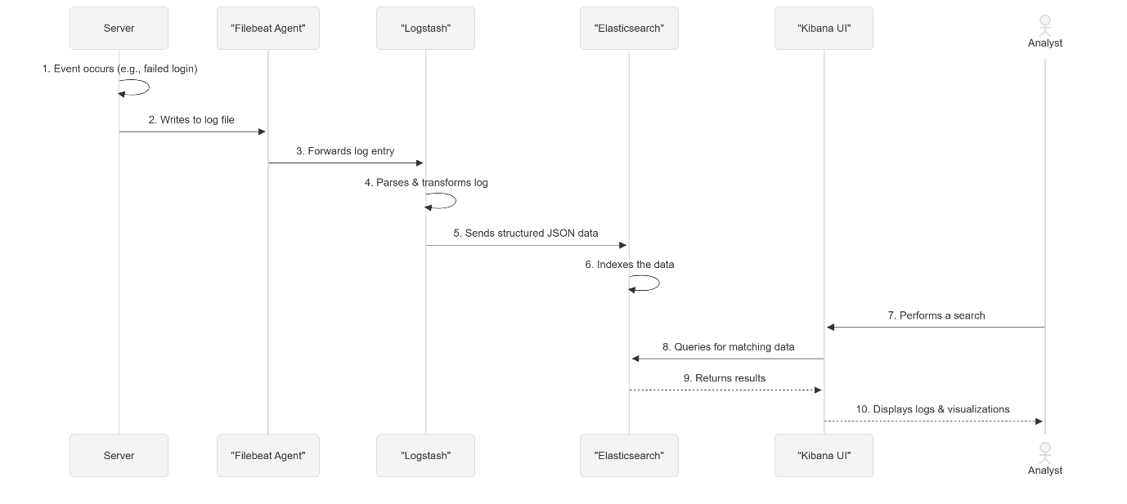
Figure 3 SEQUENCE DIAGRAM

1.6.3.4. User Interface Design
The user interface will be the Kibana web interface. This provides a highly capable and user-friendly environment out-of-the-box. The primary view will be a series of custom-built dashboards containing various visualizations like graphs of login attempts, maps of source IP addresses, and tables of critical alerts. A separate 'Discover' view will give administrators a powerful search bar to query all raw log data for deep-dive investigations.

1.7. Proposed solution Development
This section describes the development approach, technology stack, and artefacts that will be produced to implement the Centralised Security Operations Dashboard (SOC-lite) for GDCL. The implementation will follow the specifications in Section 1.6 and produce working configuration-as-code, ingestion pipelines, dashboards, alerting rules, automated deployment pipelines, and supporting scripts.

1.7.1. Development Technology and Tools Specifications

1.7.1.1. Software (programming languages, IDEs, runtime platforms)
The software stack for the Centralised Security Operations Dashboard is anchored by the Elastic Stack — Elasticsearch for indexing and storage, Logstash for processing, and Kibana for visualization — with Beats (Filebeat, Metricbeat, Winlogbeat) deployed as lightweight collectors on source systems. Scripting and glue logic will be implemented primarily in Python (3.10+) for parser scripts, ingestion helpers, alerting glue code and small microservices, with Node.js (LTS) available optionally for lightweight web services or UI widgets. Alerting and correlation may be implemented using ElastAlert2 or Elasticsearch Alerting (Watcher), selected according to licensing and operational requirements. Containerisation and environment management will rely on Docker and Docker Compose for local development and packaging, while Kubernetes (managed or on-prem) is recommended for production orchestration if GDCL requires container orchestration. Infrastructure provisioning and configuration management will be addressed with Terraform (cloud resource provisioning) and Ansible (configuration management and agent rollout). Source control will use Git (GitHub or GitLab) and CI/CD pipelines (GitHub Actions or GitLab CI) will automate linting, configuration validation, unit testing and deployments. Development environments will standardise on Visual Studio Code with relevant language and format extensions (Python, YAML, JSON, Elasticsearch). Testing and validation tools include pytest for unit tests, Elasticsearch Rally or JMeter for performance and load testing, and Filebeat/Logstash test harnesses or custom Python generators for ingestion testing. For cluster monitoring and observability, Prometheus and Grafana may be used when Elastic Monitoring is not preferred. Security testing and cryptography utilities such as OpenSSL will be used for certificate management, and controlled network/security testing in staging will employ tools like Nmap and Metasploit under strict change control.

1.7.1.2. Hardware (development and production)
Development and staging environments will consist of standard developer workstations and a small VM mini-cluster. Developer laptops should have at least 16 GB RAM, a quad-core CPU and a 512 GB SSD to support local Docker Compose stacks and development tasks. A staging VM/mini-cluster should emulate production and is recommended to include three VMs each with 8–16 GB RAM and 100–200 GB SSD for integration testing. For production, a cloud-hosted cluster is recommended for scalability and resilience. A minimal production cluster example comprises three data nodes (each 32–64 GB RAM, 8+ vCPUs, 1–2 TB NVMe SSD), three dedicated master nodes for cluster coordination and quorum, and additional coordinating/ingest nodes as required by parsing throughput and retention strategy; a hot-warm node architecture is recommended where hot nodes use fast storage for recent indices and warm nodes handle longer retention. Network-attached storage or S3-compatible object storage should be provisioned for backups and snapshots. Finally, network security appliances and segregation are required: management VLAN hardware isolation, a dedicated firewall for the management plane, and an out-of-band management network for administrative access.

1.7.2. Network specifications and deployment considerations

1.7.2.1. Network specifications
All log transport must be secured and capacity-planned. Agent traffic should use TLS-encrypted transport (for example Beats -> Logstash over TCP 5044/TLS, or Beats -> Elasticsearch over HTTPS on 9200/TLS if shipping directly). Network device syslog should use RFC5424 over TCP/TLS (port 6514) where supported. Bandwidth and throughput planning must be driven by an events-per-second (EPS) baseline; for example, if GDCL expects between 2,000 and 10,000 EPS the ingestion and network infrastructure must be provisioned accordingly with headroom for spikes and indexing overhead (approximately 1.5x). The logging and analytics cluster must be deployed on a dedicated, isolated VLAN/subnet (ingest and management networks) with access restricted by firewall rules to authorised administrative hosts and monitoring systems. High availability is achieved by redundant ingestion endpoints (multiple Logstash/ingest nodes behind a load balancer) and multiple data nodes with shard replication. Security hardening measures include mutual TLS, role-based access control for Kibana and Elasticsearch, restrictive network ACLs, and VPN or jump-host access for administrators; management interface access itself must be logged. Accurate time synchronisation via NTP or chrony across all hosts is mandatory to preserve timestamp integrity for cross-system correlation and forensic analysis.

1.7.2.2. Developed solution and associated code
The developed solution will be delivered as a set of production-ready, configuration-as-code artefacts housed in a versioned repository to enable repeatable deployments. The repository will contain infrastructure provisioning playbooks (Terraform/Ansible), container recipes and Docker Compose files for local staging, agent configuration templates for Filebeat/Metricbeat/Winlogbeat (and Wazuh agents if used), Logstash pipeline configurations including parsing and enrichment rules, Elasticsearch index templates and ILM policies, exported Kibana dashboards and saved objects, Python parser modules and their pytest unit tests, CI/CD pipeline definitions for automated validation and deployment, and operational documentation and runbooks. Configurations will be parameterised so that secrets are injected at runtime via a secrets manager and never committed to source control. Representative artefacts will include sample Filebeat and Logstash configs, parsers for common formats (firewall, syslog, HL7 where relevant), example dashboard exports (NDJSON), and CI workflows that lint, validate and test configurations before promotion to staging and production. These deliverables will support automated rollout, repeatable testing, and maintainable operational handover to GDCL’s technical team.

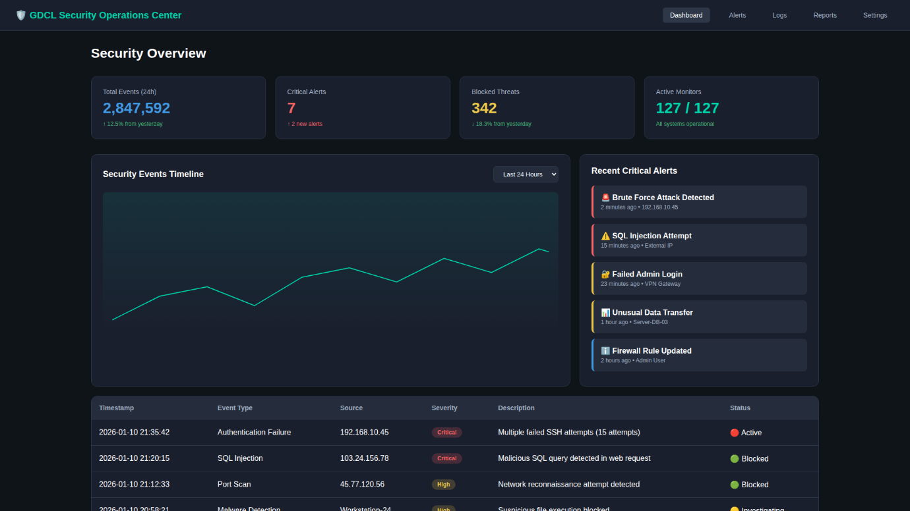
Figure 4 SECURITY OVERVIEW DASHBOARD

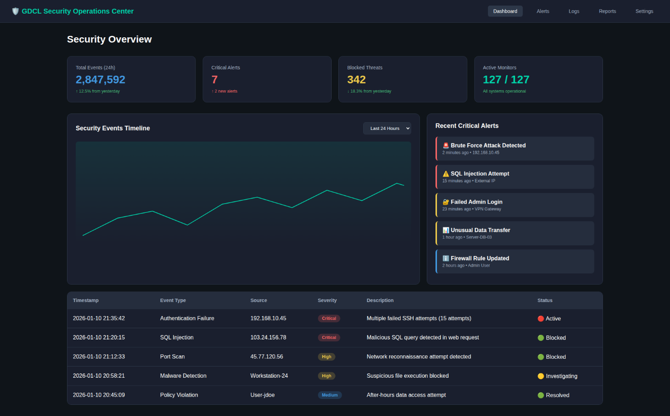
Figure 5 COMPLETE DASHBOARD VIEW

Figure 6 SECURITY METRICS

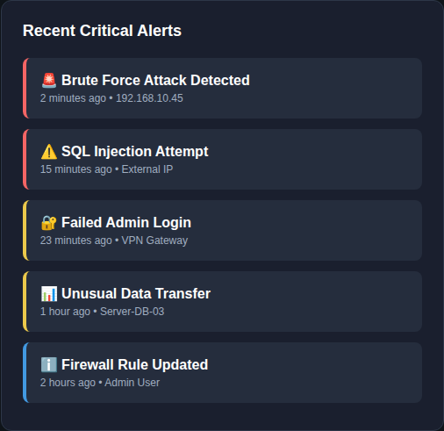
Figure 7 CRITICAL ALERTS

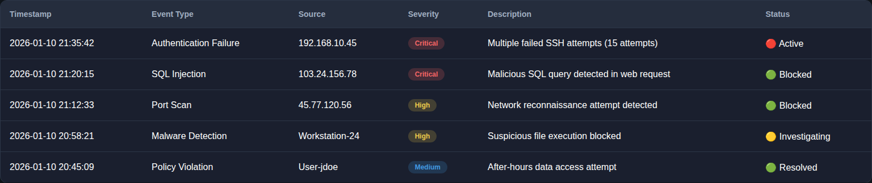
Figure 8 SECURITY EVENT LOGS

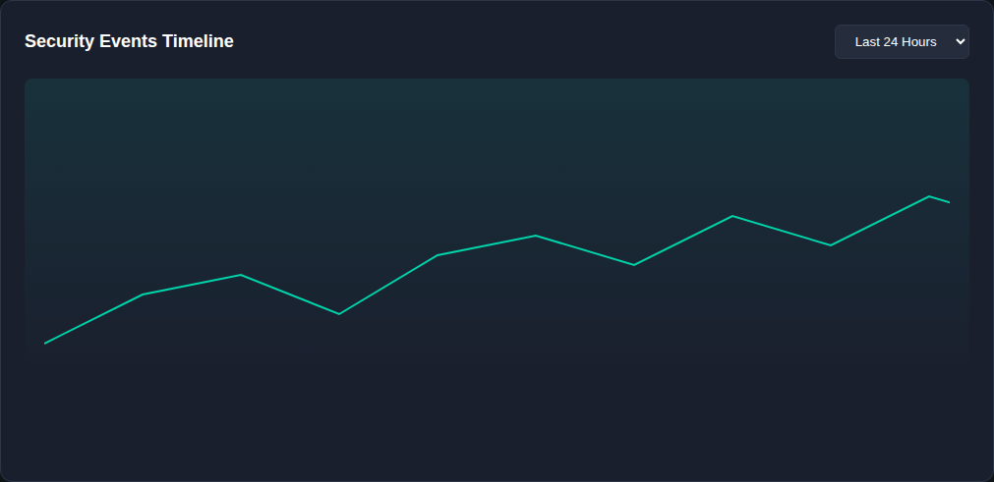
Figure 9 EVENT TIME-LINE GRAPH

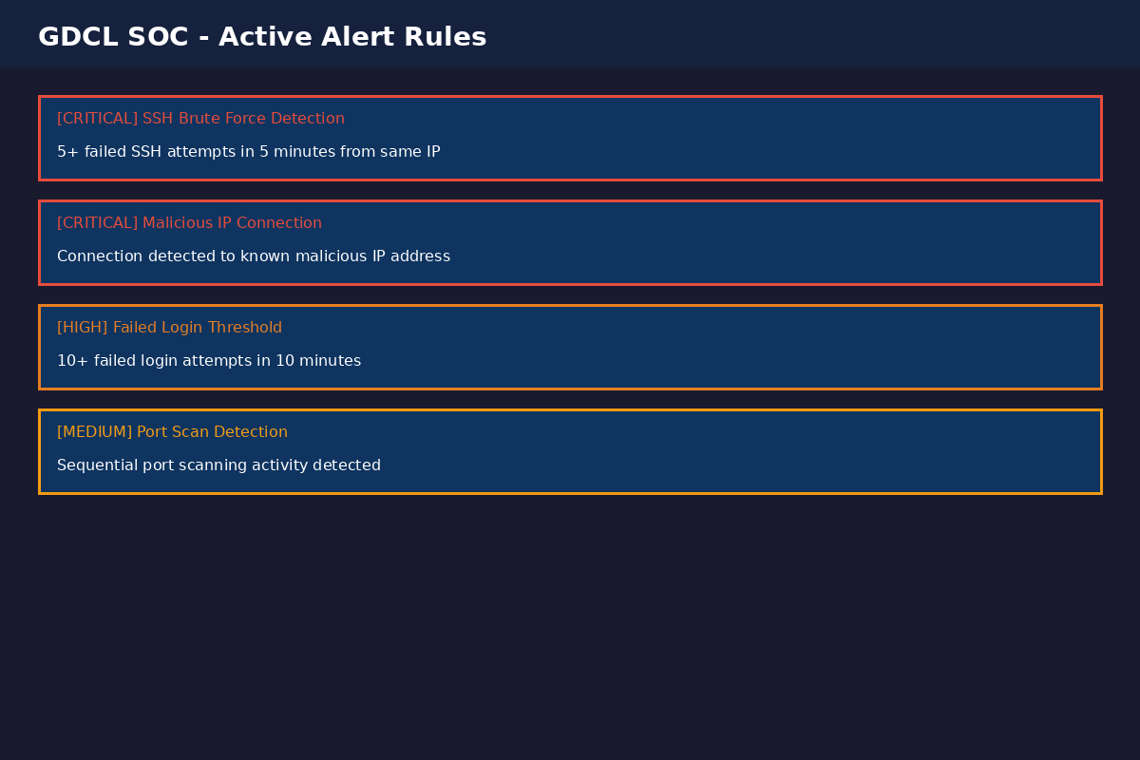
Figure 10 ALERT RULES CONFIGURATION

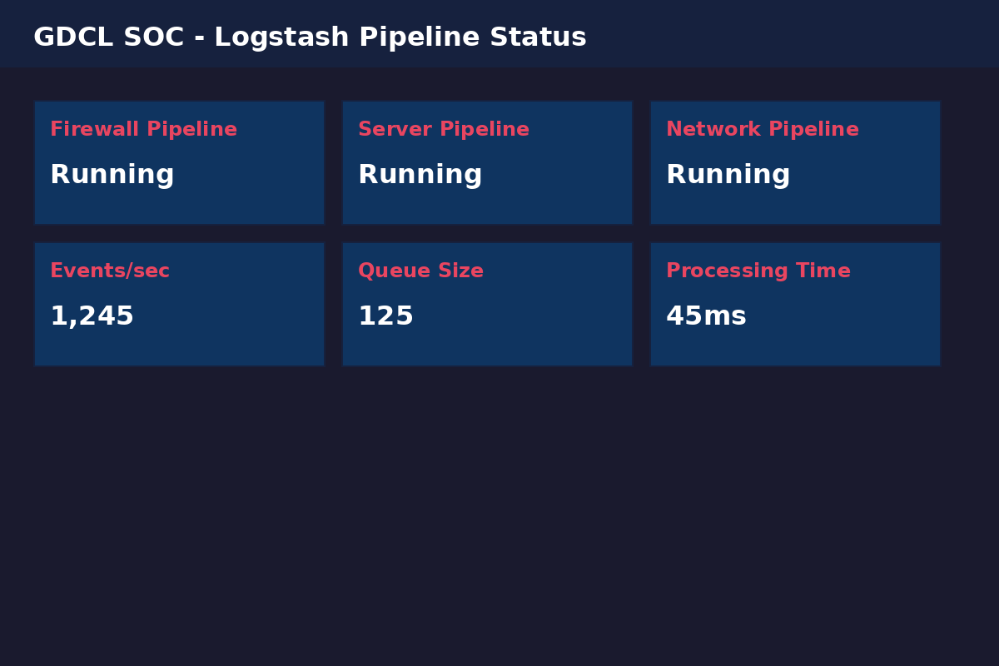
Figure 11 LOGSTASH PIPELINE STATUS

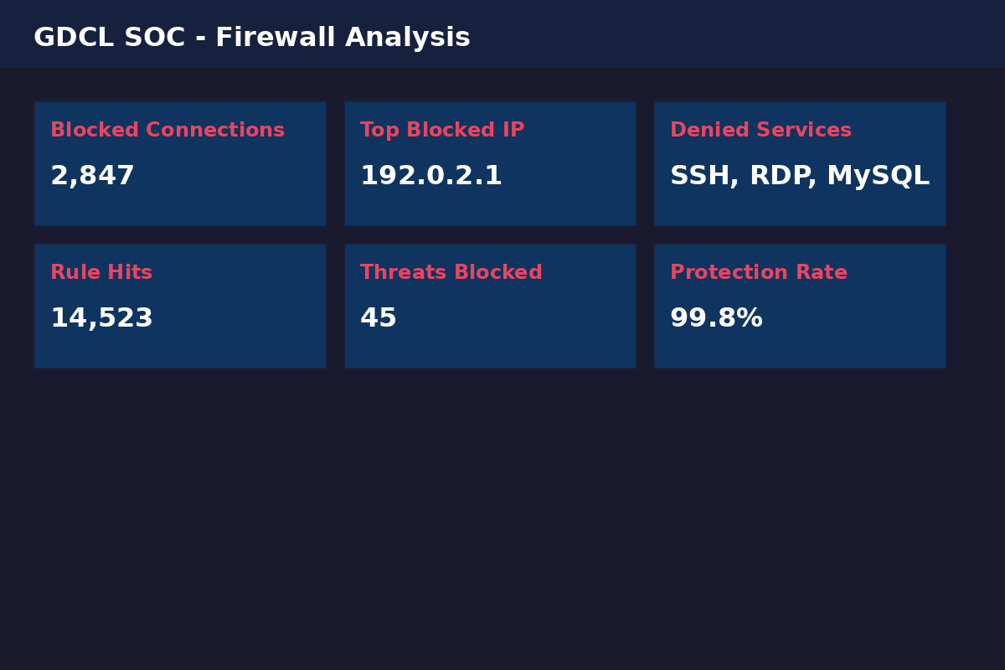
Figure 12 FIREWALL ANALYSIS DASHBOARD

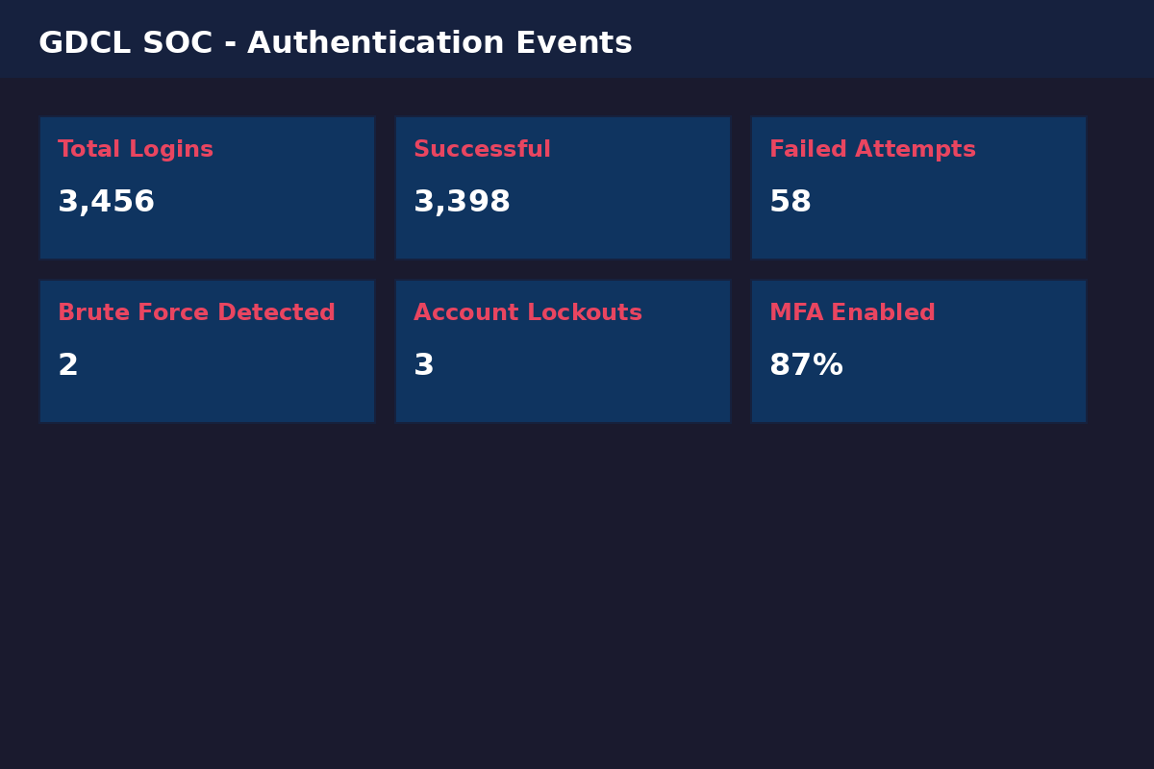
Figure 13 AUTHENTICATION MONITORING

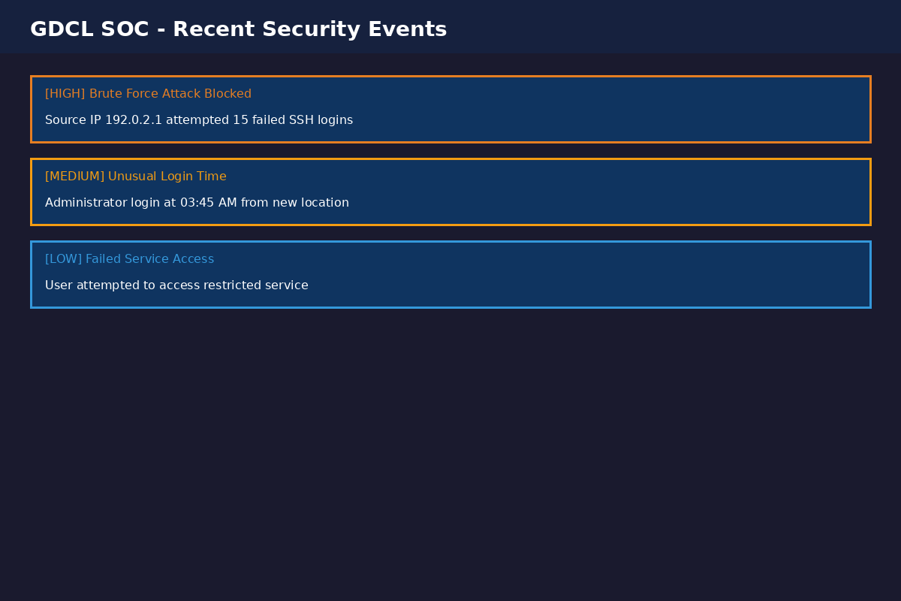
Figure 14 RECENT SECURITY EVENT

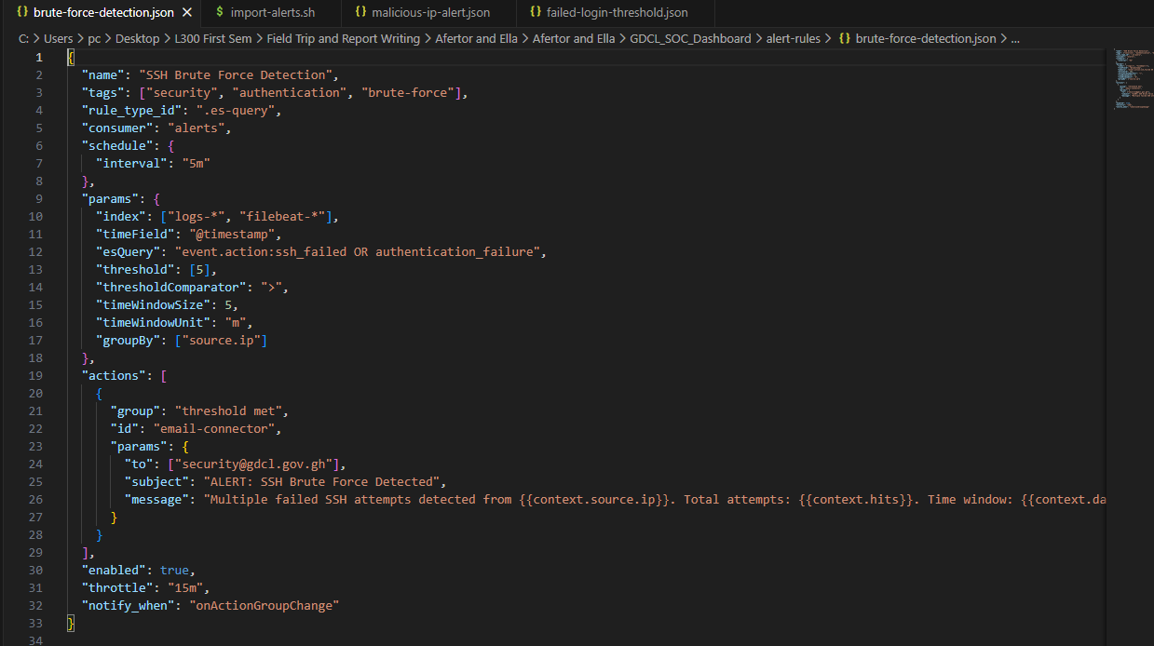
Figure 15 ALERT RULES – BRUTE-FORCE-DETECTION
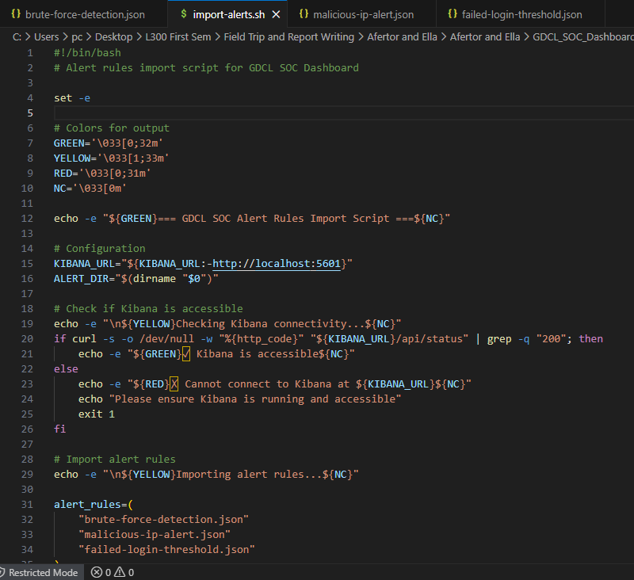
Figure 16 ALERT RULES – IMPORT ALERTS
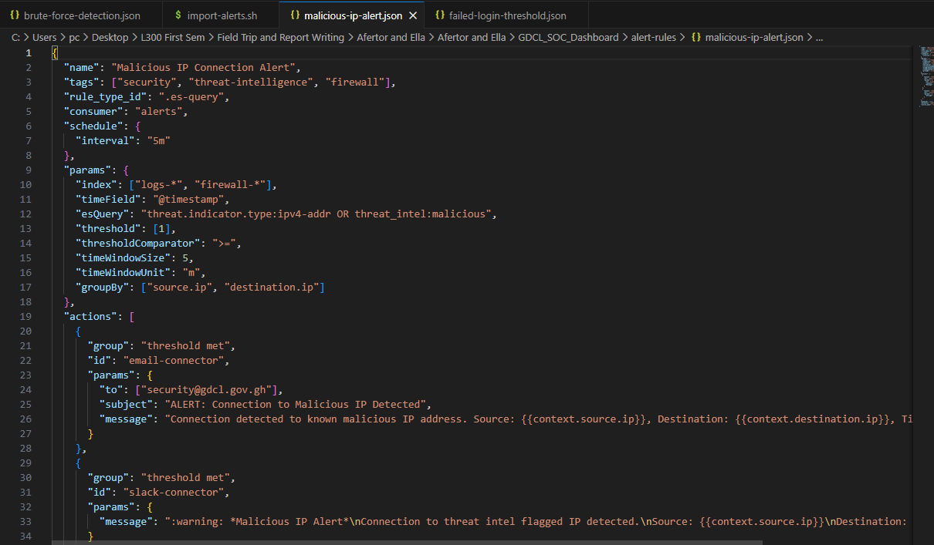
Figure 17 ALERT RULES – MALICIOUS -IP-ALERT

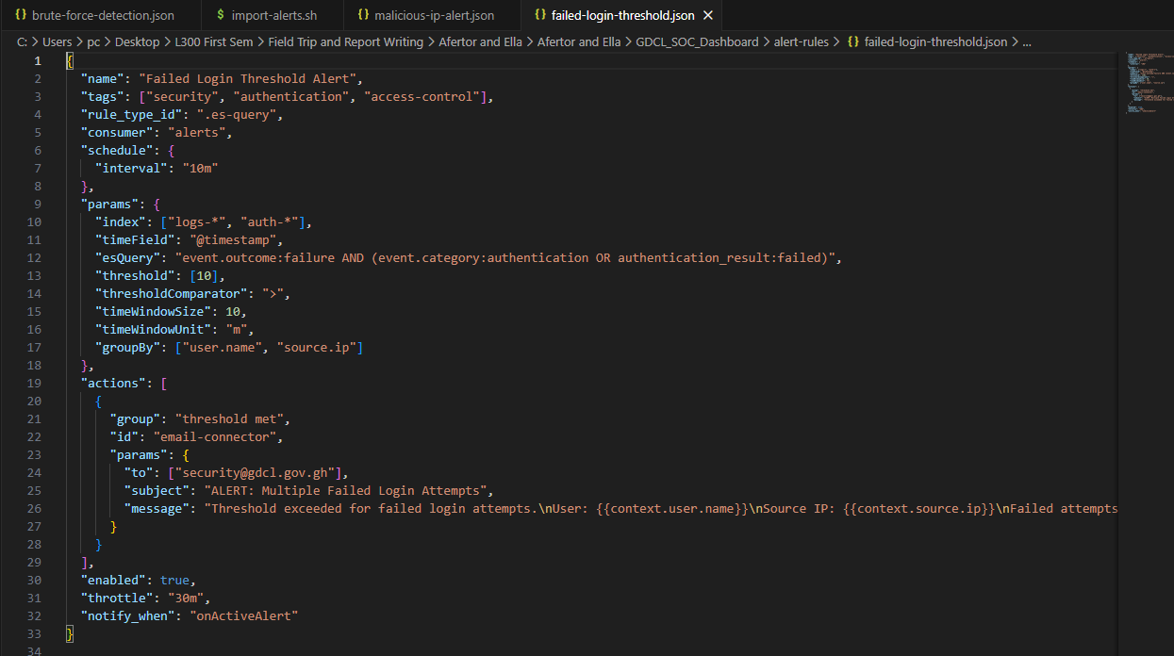
Figure 18 ALERT RULES – FAILED-LOGIN-THRESHOLD
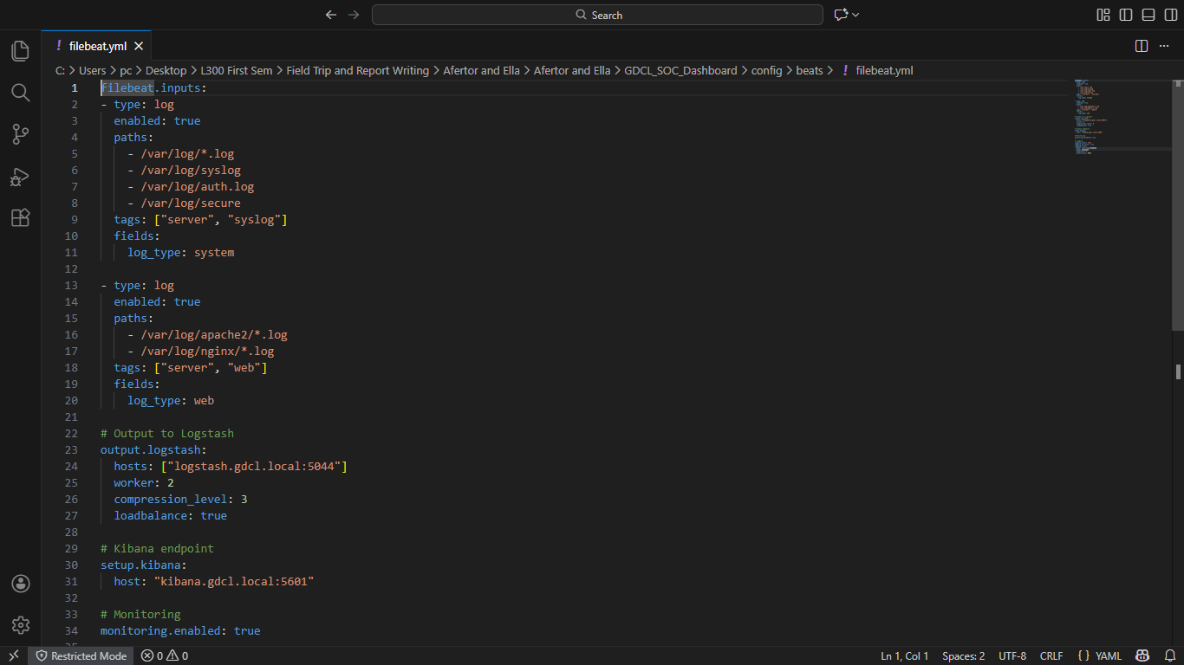
Figure 19 CONFIG - FILEBEAT

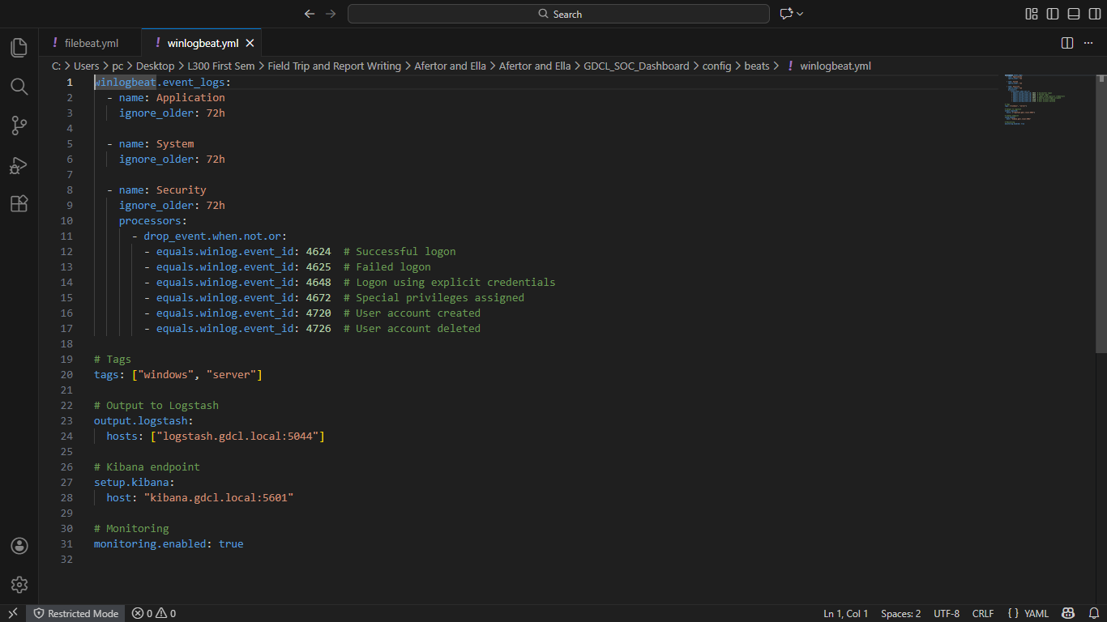
Figure 20 CONFIG - WINLOGBEATS

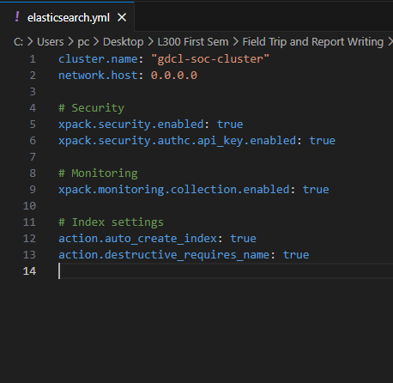
Figure 21 CONFIG – ELASTICSEARCH

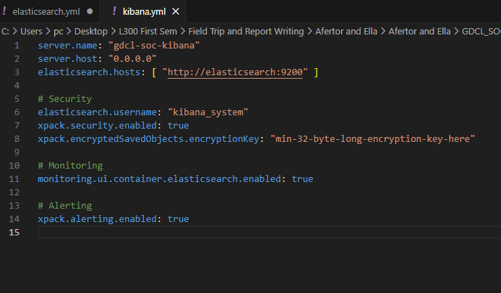
Figure 22 CONFIG – KIBANA

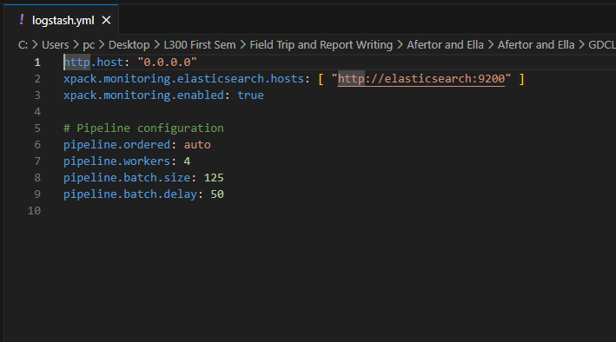
Figure 23 CONFIG - LOGSTASH

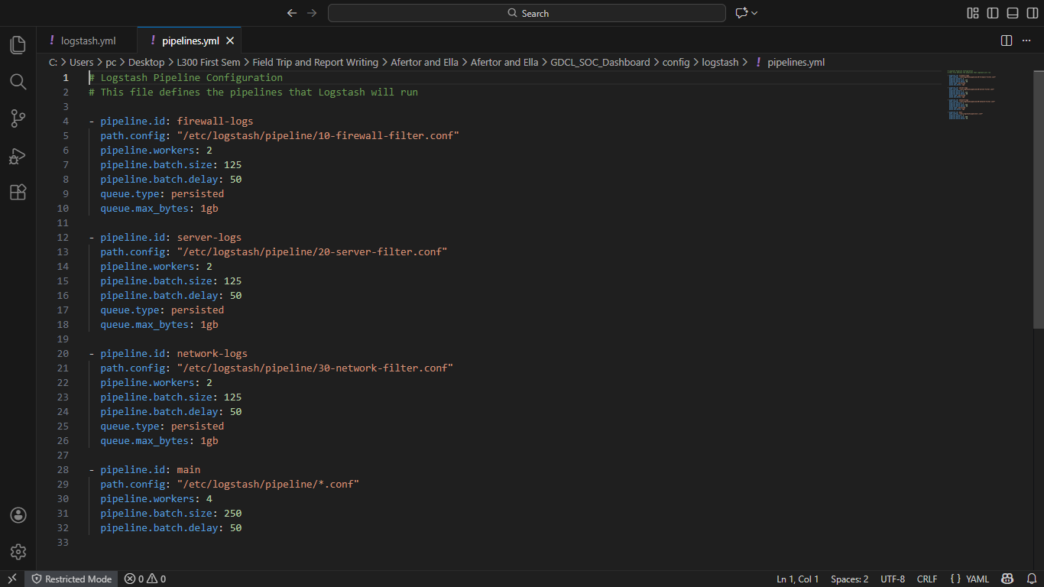
Figure 24 CONFIG - PIPELINES

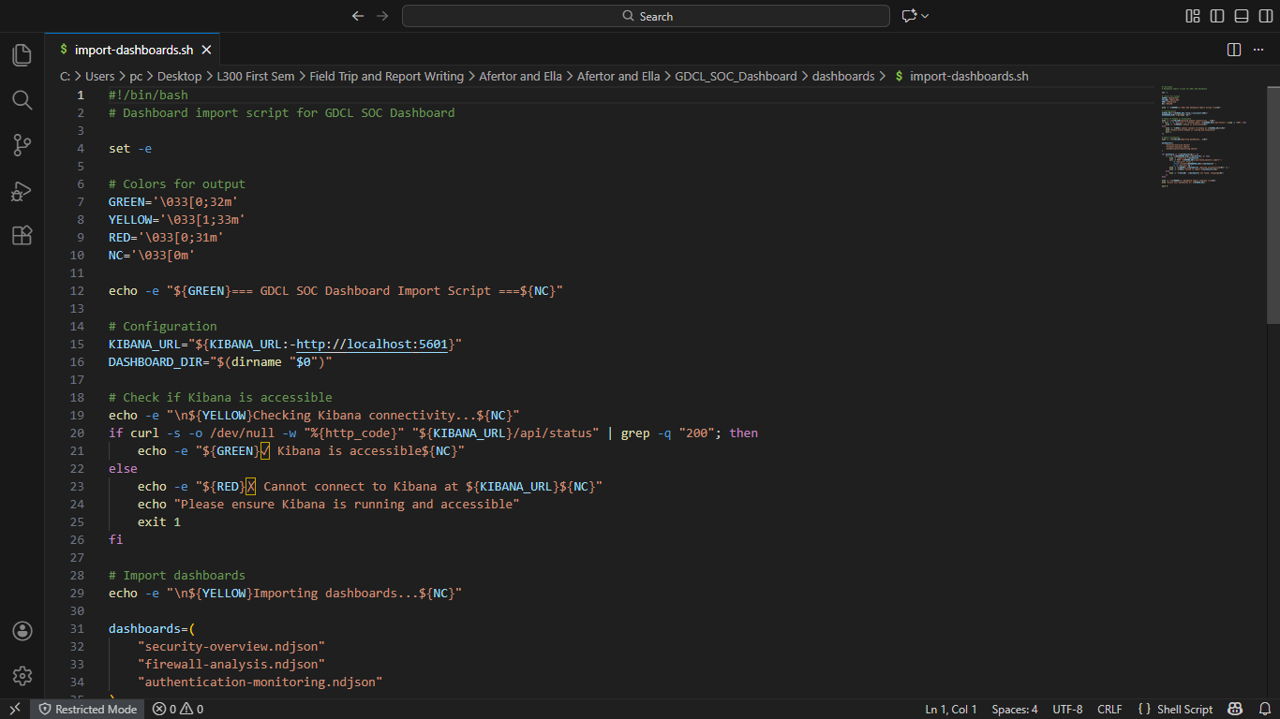
Figure 25 DASHBOARD

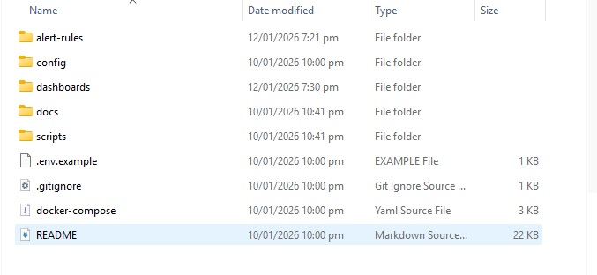
Figure 26 OTHER FILES

1.8. SYSTEM TESTING
A formal test plan will be executed in the staging environment to validate individual components and the end-to-end solution; testing is organised into unit, integration and system testing phases to ensure the implementation meets both functional and non-functional requirements before production cut-over.

1.8.1. Unit Test Purpose
Unit testing will validate individual functions and parsing rules in isolation. The scope covers parser functions (Python) that must produce correct structured output from representative sample logs and configuration validators that check Beats and Logstash configuration files against YAML/JSON schemas. Tests will be implemented with pytest for parser and module unit tests (targeting a high coverage threshold for parsing modules) and with yamllint/jsonschema checks for configuration files. Representative cases include a valid firewall log that parses to a dictionary with expected fields, malformed logs that raise predictable and safely handled errors, and Logstash pipeline syntax checks that ensure no deprecated plugins are present. Acceptance criteria for unit testing require all unit tests to pass automatically in CI for every commit and for all configuration files to validate successfully against their schemas prior to deployment.

1.8.2. Integration Testing Purpose
Integration testing will verify the interaction between components in the full telemetry pipeline (Beats → Logstash → Elasticsearch → Kibana → alerting). The scope includes end-to-end ingestion of varied log types (firewall, server syslog, Windows event logs), validation that alerting rules trigger expected notifications when synthetic incidents are injected, and confirmation that role-based access control is enforced and dashboards render the expected visualisations. The integration environment will be provisioned automatically using Docker Compose or a Kubernetes staging cluster, and test harnesses will replay historical logs or generate synthetic traffic to simulate normal and malicious activity; ElastAlert runners or Watcher simulations will be used to verify alert triggers. Example integration tests include ingesting a batch of 10,000 firewall logs and confirming they are indexed and that a preconfigured correlation rule fires for a simulated brute-force pattern, and validating that a Kibana dashboard aggregates results correctly and permits drill-down to raw events. Acceptance criteria require that ingested logs are indexed and searchable within the target SLA (for example, recent events searchable in under five seconds), that each alerting rule fires for the expected synthetic scenario and delivers notifications to configured endpoints, and that parsing failures are absent or documented with handling strategies.

1.8.3. System Testing Purpose
System testing will validate system behaviour under realistic operational conditions with emphasis on performance, resilience, security and recoverability. The testing scope includes performance and scalability tests to verify the cluster can handle sustained EPS and peak bursts, failover and resilience tests such as node termination and network partitioning with recovery validation, security testing including vulnerability scans, access control verification, TLS configuration checks and limited penetration testing in staging, and backup/restore tests for Elasticsearch snapshots and index recovery. Tools and approaches will include Elasticsearch Rally for indexing and query benchmarking, JMeter or custom Python scripts to generate steady and burst traffic patterns, chaos testing techniques to validate replica promotion and availability, and security scanners such as OpenVAS or Nessus (with authorisation) alongside Nmap and manual RBAC reviews. Representative system tests include a sustained 10,000 EPS load for one hour to measure ingestion latency and cluster health, terminating a data node to validate recovery to a green cluster state without data loss, and performing a snapshot restore to a fresh cluster to verify index integrity. Acceptance criteria mandate that the cluster maintains acceptable ingestion latency under target EPS and remains stable, that the system recovers to a healthy state after node failures without data loss beyond the defined RPO, and that all critical vulnerabilities identified during security scanning are triaged and remediated prior to production cut-over.
Deliverables from testing and artefacts produced
The testing programme will produce a formal test plan and test case documents traceable to the system requirements, CI pipelines that execute unit and integration tests automatically, performance test reports (Rally/JMeter outputs) with recommended scaling adjustments, a security assessment report with remediation timelines, and operational runbooks for common tasks including index rollover, snapshot/restore and incident response playbooks. Implementation artefacts that will accompany these deliverables include configuration files for Filebeat and Logstash pipelines, Elasticsearch index templates and ILM policies, parser modules and associated unit tests, exported Kibana dashboards and saved objects (NDJSON), CI/CD pipeline definitions for linting, testing and deployment, and infrastructure-as-code (Terraform/Ansible) to provision and configure staging and production environments.

References
ENISA (European Union Agency for Cybersecurity). (2022). ENISA Threat Landscape 2022. Available at: https://www.enisa.europa.eu/publications/enisa-threat-landscape-2022 (Accessed: 4 December 2025).
Fowler, M. (2005). The New Methodology. Available at: https://martinfowler.com/articles/newMethodology.html (Accessed: 4 December 2025).
Gartner, Inc. (2021). Magic Quadrant for Security Information and Event Management. Available at: https://www.gartner.com/en/documents/4007233 (Accessed: 4 December 2025).
GDCL (Ghana Digital Centres Limited). (2023). Our Services. Available at: https://www.adc.gov.gh/services (Accessed: 4 December 2025).
Government of Ghana. (2012). Data Protection Act, 2012 (Act 843). Accra: Ghana Publishing Company.
ISACA. (2023). State of Cybersecurity 2023: Global Update on Workforce Efforts, Resources and Budgets. Available at: https://www.isaca.org/quizzes/state-of-cybersecurity-2023 (Accessed: 4 December 2025).
Ministry of Communications and Digitalisation, Ghana. (2022). Ghana Digital Economy Policy. Accra: Government of Ghana.
NIST (National Institute of Standards and Technology). (2020). Security and Privacy Controls for Information Systems and Organizations. NIST Special Publication 800-53 Rev. 5. Gaithersburg, MD: U.S. Department of Commerce.
SANS Institute. (2022). Effective Strategies for Preventing Analyst Burnout. Available at: https://www.sans.org/white-papers/ (Accessed: 4 December 2025).

